How to create Azure data factory

Go to search bar search azure data factories

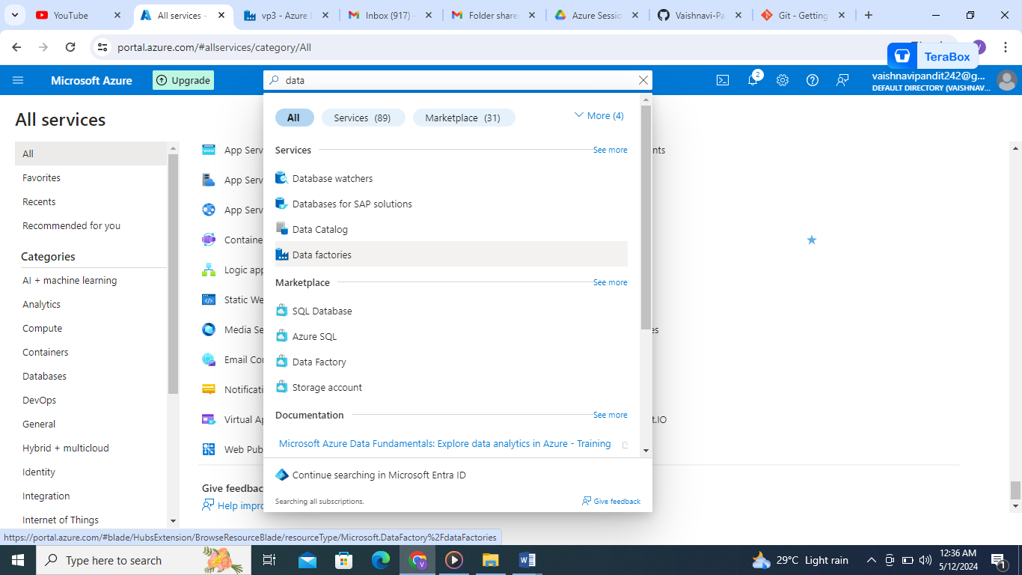

Enter create datafactory with name vp3 and resource group vp

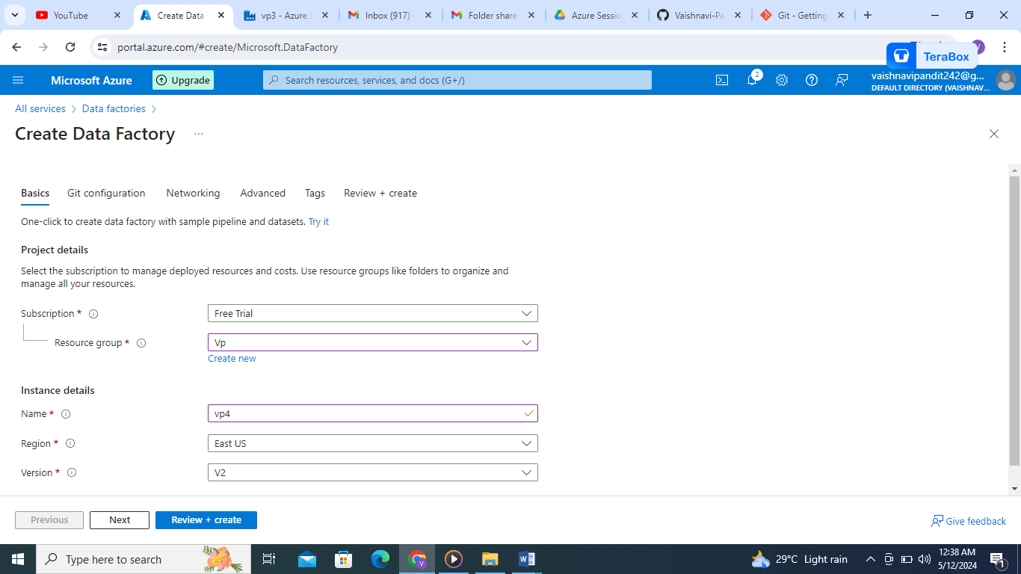

Enter preview and create

Go to resource group

Go to vp4 data factory

Enter launch studio

